**TASK 1**

Creating LXC containers and displaying those containers in the dashboard created.

* Setting up LXC containers and creating containers

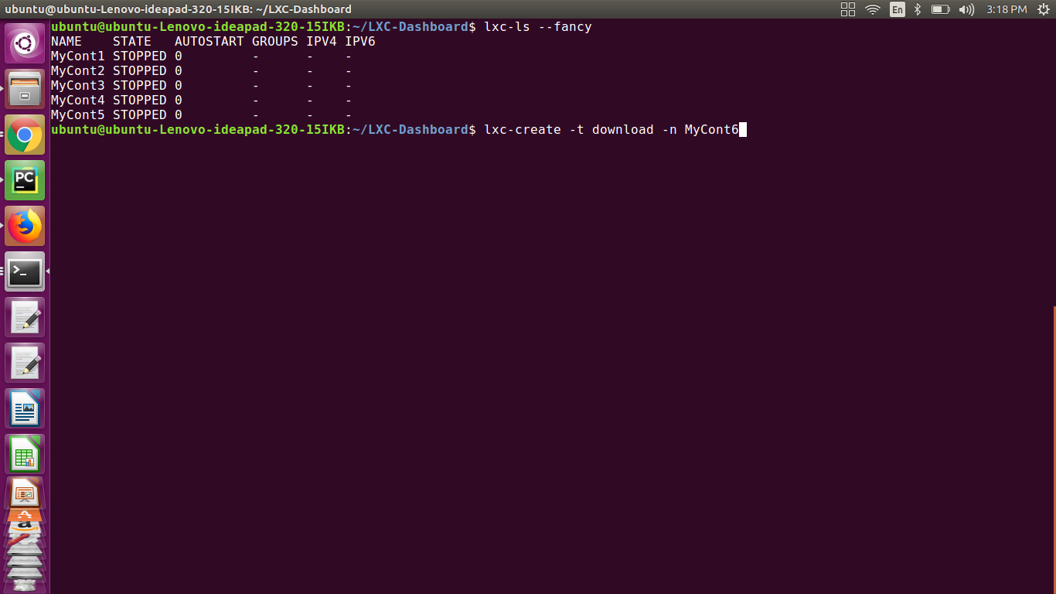

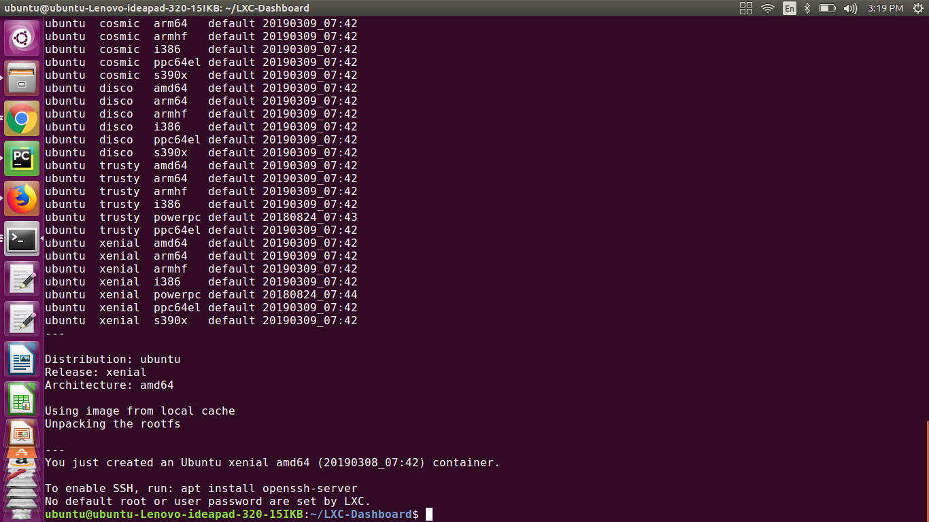

* Listing containers after creation of containers

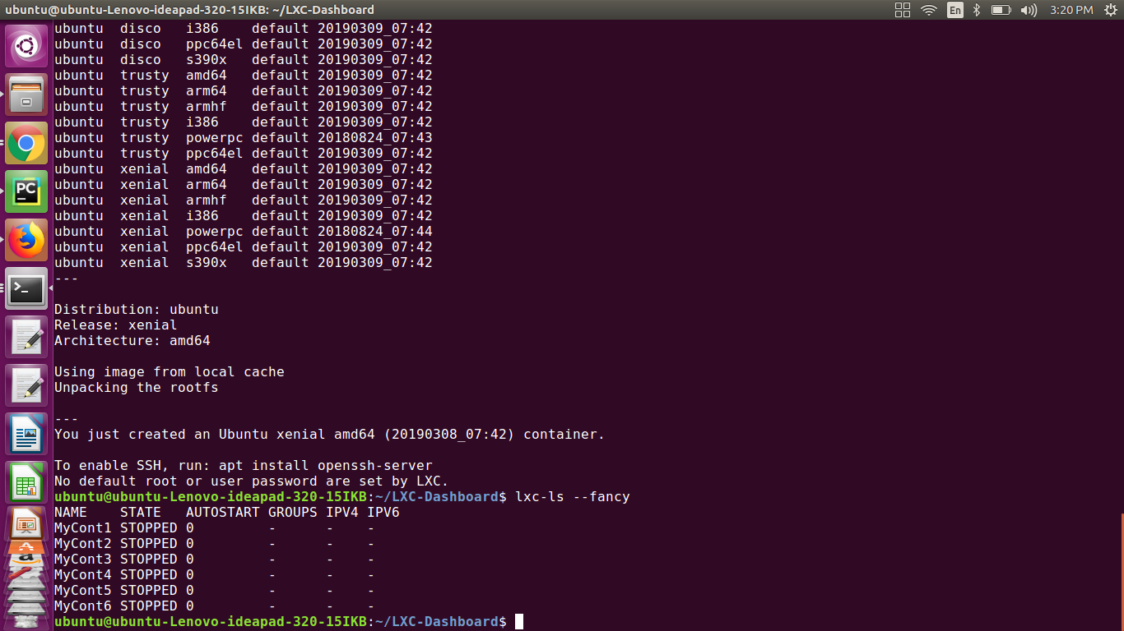

* Simple dashboard that will show the containers created in the terminal

